Bash Script Tasks
- Create a bash script to check if a directory is available or not.
Need to create the file Directory and write the script and and view the content of that file cat Directory and give permission to the file chmod 777 directory. Finally check the output whether it is available or not using command ./Directory
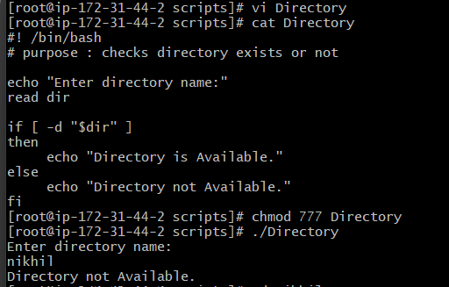
Here directory nikhil is not available so the else condition as worked.
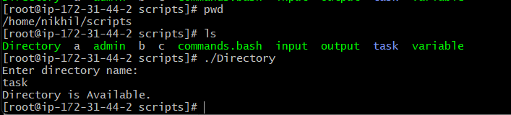
- Create a bash script to create multiple files.
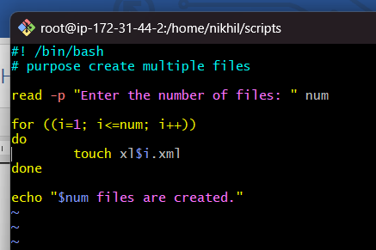
Here file.bash file is created and written the script. Here to create no of files we used for loop condition.
after giving the permission to the file we executed with ./file.bash for output.
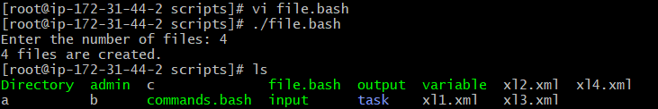
- Create a bash script to take a backup of a directory.
Here script file named as backup.file and given permission viewed the content of file with cat command. Source is a variable is used to read the file which we want to create the backupfile. Dest is a variable to read the path of the file to which location the backup file is created.
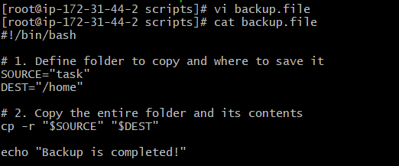
In the above executed command
cp : The standard Linux command used to copy files and folders.
-r : Stands for recursive. This flag is mandatory because it tells the script to copy the folder, all of its subfolders, and every file hidden inside them.
After giving the permission of the file need to execute the command as ./backup.file for the output.
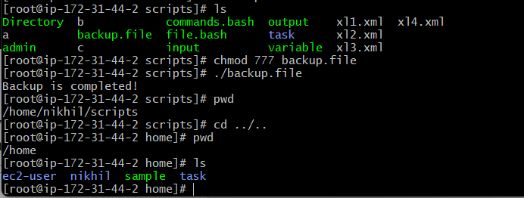
- Create a bash script to install Nginx on an EC2 server.
created file named as nginx and given the script. We can view the script with help of command cat nginx
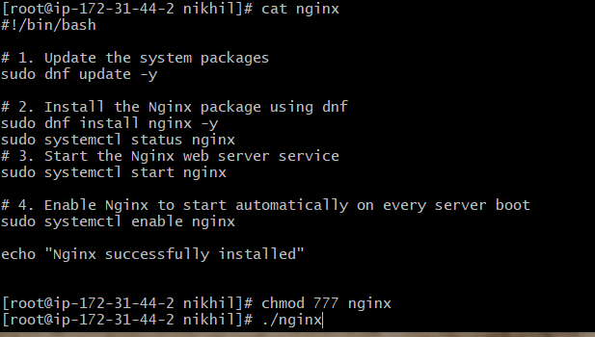
Update the System Packages (sudo dnf update -y)
- What it does: Refreshes the server's package repositories and updates existing system applications to their latest secure versions.
- Why it matters: The -y flag stands for "yes," which automatically grants permission for updates so the script runs continuously without pausing for manual user input.
Install Nginx (sudo dnf install nginx -y)
- What it does: Downloads and installs the Nginx web server software package directly onto the EC2 instance using the standard dnf package manager for Amazon Linux.
- Why it matters: This step automatically creates all necessary core directories on the server, including the default web hosting directory located at /usr/share/nginx/html.
sudo systemctl status nginx
We can check the status of nginx whether it is active or not.
Start the Nginx Service (sudo systemctl start nginx)
- What it does: Actively launches the Nginx master and worker processes in the system background.
- Why it matters: This switches Nginx from an idle, installed package into an active software service capable of listening for and responding to inbound web traffic.
Enable Auto-Start on Boot (sudo systemctl enable nginx)
- What it does: Registers Nginx with the system manager boot configuration.
- Why it matters: This ensures that if the EC2 instance is ever rebooted, stopped, or restarted for maintenance, the Nginx web server will turn itself back on automatically without requiring a system administrator to log in and start it manually.
- Finally we can browse it on web using public ip.
- 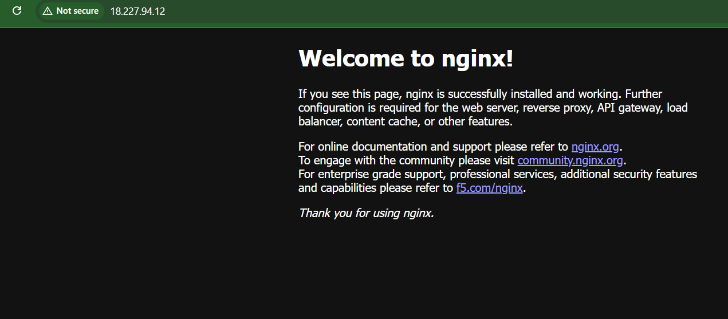

- Create a bash script to install Apache Tomcat on an EC2 server.
created file named as tomcat.bash and given the script. We can view the script with help of command cat tomcat.bash
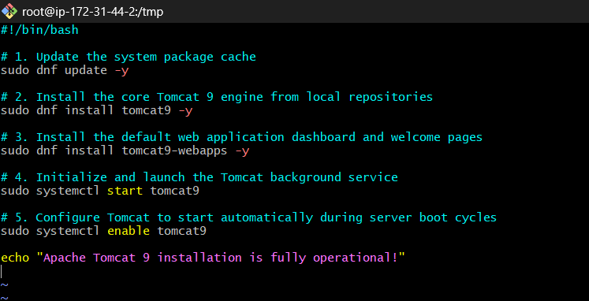
Give permissions and execute ./tomcat.bash for output
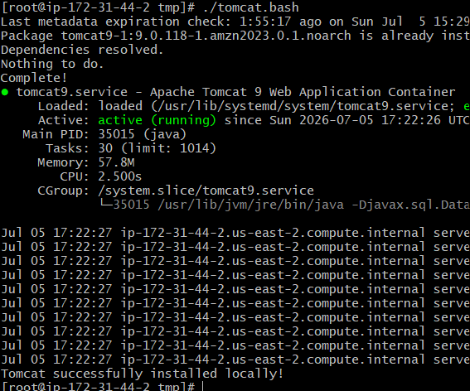
System Package Update (sudo dnf update -y)
Ensures all existing security patches and operating system links on the Amazon Linux 2023 EC2 instance are updated before adding new services.
Core Engine Deployment (sudo dnf install tomcat9 -y)
Downloads and sets up the fundamental Apache Tomcat binary libraries and background system components directly from secure, internal AWS repository clouds.
Web Application Installation (sudo dnf install tomcat9-webapps -y)
Populates the empty server root folder (/var/lib/tomcat9/webapps/ROOT/) with standard web interfaces.
Manual Service Initialization (sudo systemctl start tomcat9)
Spawns active Java worker routines in the background, shifting the server state from idle configuration files to an active network state.
Boot Optimization Registry (sudo systemctl enable tomcat9)
Injects startup directives into the system framework, guaranteeing the server boots up automatically after any sudden infrastructure power cycles.
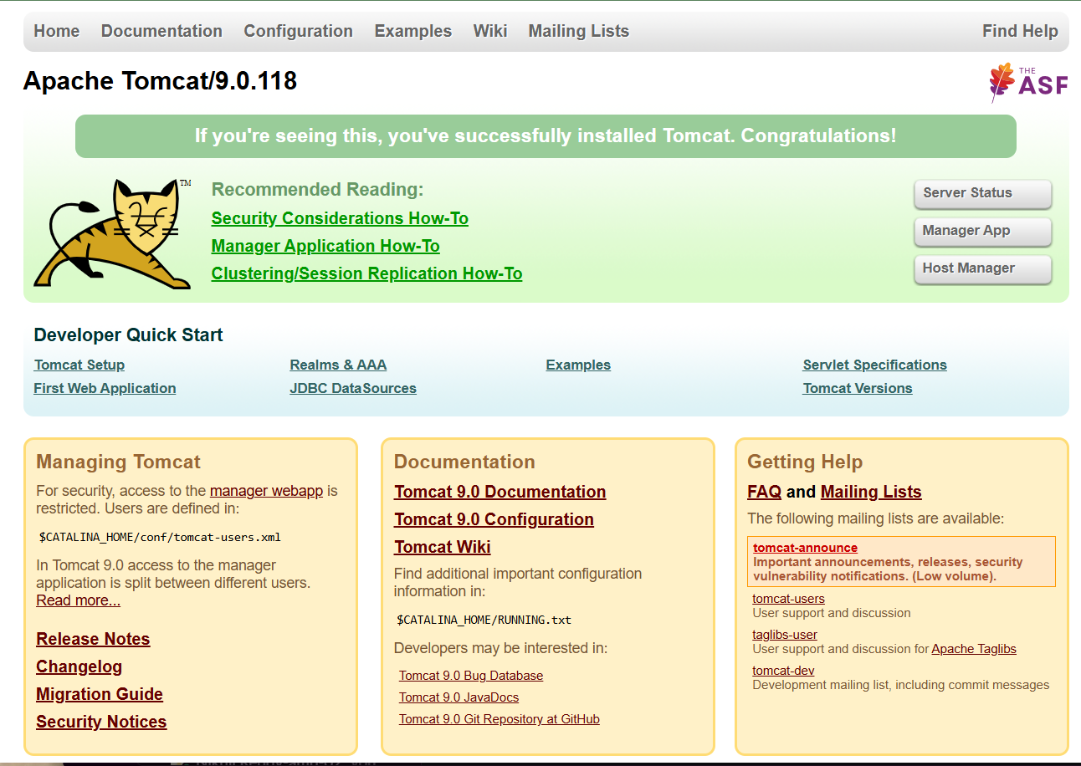
- Create a bash script to check if the Nginx service is running, if not running then script should start the service.
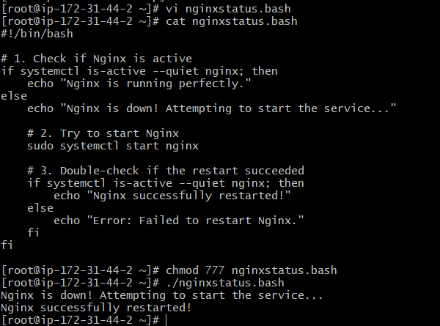
if systemctl is-active --quiet nginx; then
This uses the built-in system manager tool (systemctl) to check the live status of Nginx. The --quiet flag suppresses any messy text output on your screen, allowing the script to silently check if the service is "active" or "inactive".
- echo "Nginx is running perfectly."
If the check passes (meaning Nginx is alive), the script prints this text and exits safely without doing anything else.
- sudo systemctl start nginx
If the check fails (meaning Nginx is dead or stopped), the script enters the else block and runs this command to force the Nginx web server back online.
- The Nested if Check
After running the start command, the script runs a final check to confirm whether Nginx successfully came back online or if a deeper configuration error kept it down.
- Create a bash script for a calculator.
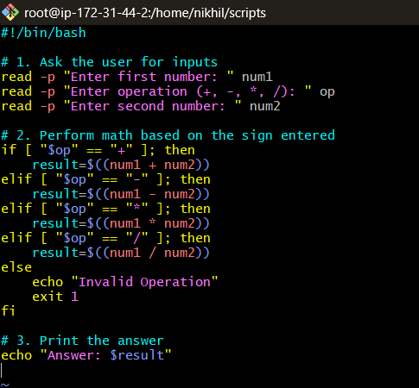
- read -p "..." variable
Pauses the script, prints a prompt message, and captures the user's typing into a stored shortcut label (num1, op, num2).
- if [ "$op" == "+" ]; then
A basic conditional check. It compares the text inside the $op variable to see if it matches the standard math symbols.
- $((num1 + num2))
This double-parenthesis syntax is the built-in Bash feature for integer arithmetic. It tells Linux to process the values inside as mathematical numbers instead of plain text strings.
- exit 1
Instantly stops and shuts down the script if the user enters a symbol the program cannot calculate
output
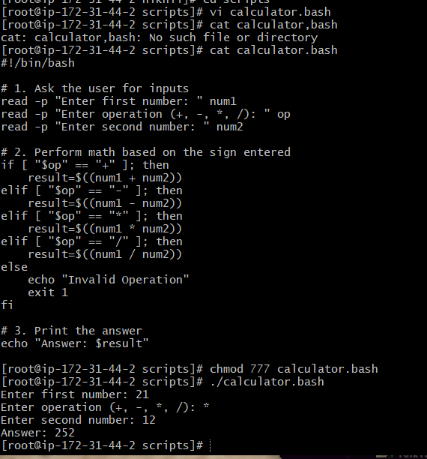
- Create a bash script to check if a directory exists, if not then create a directory.
  - DIR_NAME="my_folder"
Defines a variable to hold the name or absolute path of the directory you want to check. You can change "my_folder" to any path, like "/home/admin/backup_data".
  - if [ ! -d "$DIR_NAME" ]; then
This is the core conditional check:
  - The -d flag checks if the specified path exists and is a directory.
  - The exclamation mark ! stands for NOT.
  - Together, ! -d asks the system: "Is it true that this directory does not exist?"
  - mkdir "$DIR_NAME"
The standard Linux "make directory" command. This line only triggers if the previous if condition proves true (meaning the folder is missing).
  - else
Tells the script what to do if the condition is false—meaning the directory is already present on the system
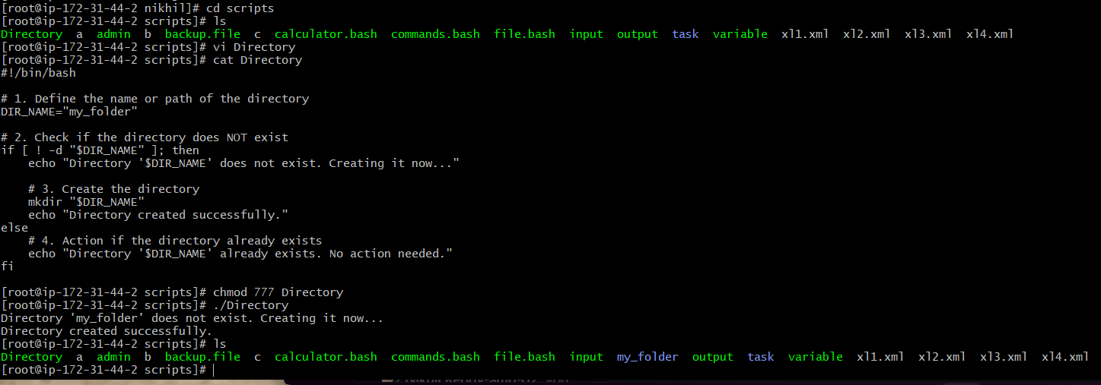
- Create a bash script to delete the last 3 lines of a file.
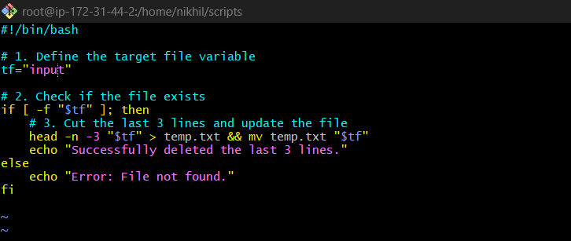

- tf="data.txt"
Defines a target variable named tf to hold the exact file name or path that needs to be shortened.

- if [ -f "$tf" ]; then
Validates that the file name assigned to tf exists and is a regular readable file before running any text processing commands.
- head -n -3 "$tf"
Reads the content of the file and instructs the system to output everything except for the final 3 lines.
- > temp.txt
Takes the shortened text stream and writes it into a clean, temporary file named temp.txt.
- && mv temp.txt "$tf"
The && ensures this step runs only if the file reduction succeeds. The mv command instantly replaces the original file with the new, shortened version without generating extra copies.
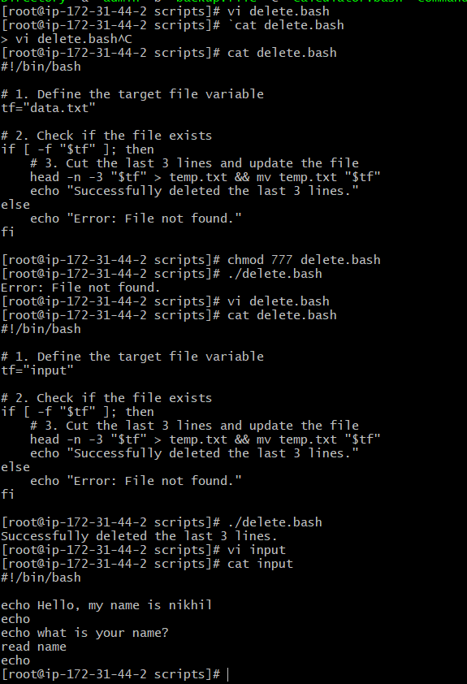
- Bash script to monitor cpu and if it is more than 80% then send email notification.
created file as email.bash and script can be view as cat email.bash
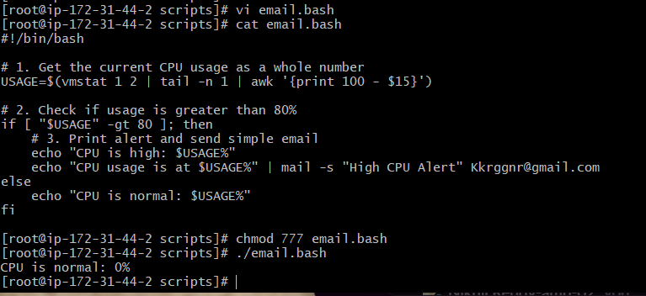
  - vmstat 1 2
A built-in tool that collects quick system performance data. It takes two rapid measurements to calculate accurate system activity.
  - awk '{print 100 - $15}'
The 15th column of the vmstat output shows the CPU idle time. Subtracting this number from 100 instantly gives you the active CPU workload.
  - if [ "$USAGE" -gt 80 ]
A basic check to see if the current workload number is greater than (-gt) 80.
  - mail -s "..." email
Sends a quick email with the specified subject (-s) to your administrator email address.
- Bash script to monitor disk space and if it is more than 80% then send email notification.
created file as disk.bash and script can be view as cat disk.bash
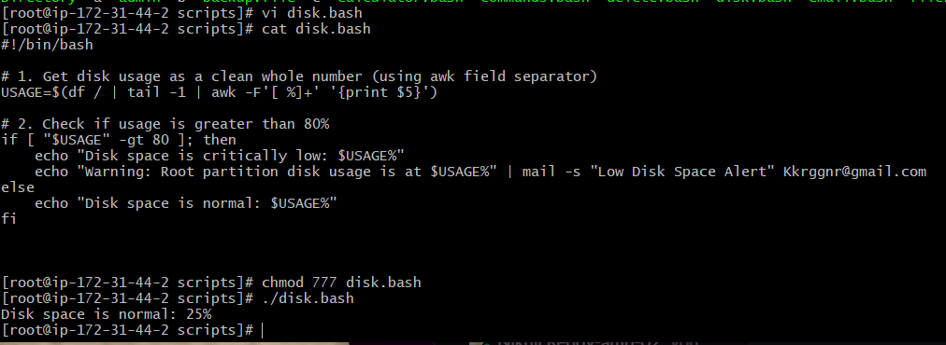
- df /: Queries the storage filesystem status specifically for the primary root disk partition.
- tail -1: Discards the descriptive top header row (Filesystem Size Used...) and isolates the final row containing the actual numeric system values.
- awk -F'[ %]+' '{print $5}': The -F flag alters the standard delimiter field separator. By declaring [ %]+, awk treats both empty white spaces and percentage symbols as data separators. This drops the trailing % character, allowing column 5 to be saved into system memory as a clean integer variable
- Bash script to monitor memory and if it is more than 80% then send email notification.
created file as memory.bash and script can be view as cat memory.bash
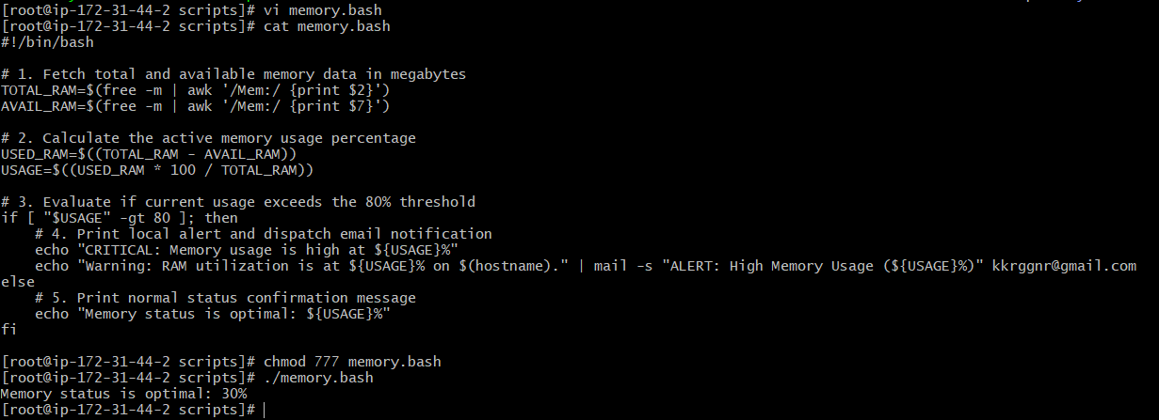
- free -m
Queries the Linux kernel for live memory allocation values. The -m flag forces the tool to output all measurements in megabytes (MB) for easy calculation.
- awk '/Mem:/ {print $2}'
Filters the output of the free command to target the specific row containing physical RAM (Mem:). It isolates and saves column 2 (Total RAM) and column 7 (Available RAM) into respective variables.
- $((USED_RAM * 100 / TOTAL_RAM))
Uses standard native Bash double-parenthesis integer arithmetic. It multiplies the consumed RAM by 100 before dividing it by the total system capacity to calculate a clean whole percentage integer (e.g., 42 instead of 42.5%). This approach avoids fractional strings that break native Bash conditional operators.
Exercise: Crontab Entries

April 5th Midnight

Objective
Create a cron job that executes the script crontab01.bash every year on April 5th at 12:00 AM (Midnight).

Prerequisites
- Operating System: Amazon Linux
- Script Location:
/home/nikhil/scripts/crontab01.bash

Step 1: Verify the Script
Check whether the script exists.
ls -l /home/nikhil/scripts/crontab01.bash
Sample Output:
-rwxrwxrwx. 1 root root 81 Jul 6 09:20 /home/nikhil/scripts/crontab01.bash

Step 2: Make the Script Executable
Verify the permissions.
ls -l /home/nikhil/scripts/crontab01.bash

Step 3: Edit the Script
Open the script using the vi editor.
vi /home/nikhil/scripts/crontab01.bash
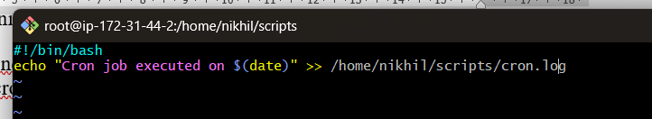

Step 4: Open the Crontab Editor
crontab -e

Step 5: Add the Cron Entry
Insert the following line at the end of the file.
0 0 5 4 * /home/nikhil/scripts/crontab01.bash
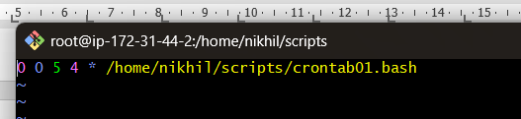

Cron Expression Explanation
Field | Value | Description
Minute | 0 | At 0 minutes
Hour | 0 | At Midnight (12:00 AM)
Day of Month | 5 | 5th Day
Month | 4 | April
Day of Week | * | Every day of the week

Step 6: Verify the Cron Entry
crontab -l
Expected Output
0 0 5 4 * /home/nikhil/scripts/crontab01.bash

Step 7: Check the Cron Service
Since Amazon Linux uses crond, verify that the service is running.
sudo systemctl status crond
If the service is not running, execute:
sudo systemctl start crond
sudo systemctl enable crond

Step 8: Test the Script Manually
Run the script manually.
/home/nikhil/scripts/crontab01.bash

Step 9: Verify the Log File
Display the contents of the log file.
cat /home/nikhil/scripts/cron.log
Sample Output
Cron job executed on Mon Jul 6 09:20:37 UTC 2026
Cron job executed on Mon Jul 6 09:22:07 UTC 2026

Final Cron Entry
0 0 5 4 * /home/nikhil/scripts/crontab01.bash

Result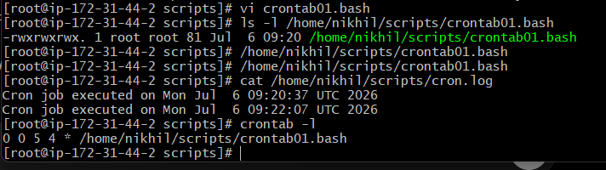
The cron job is configured successfully and will execute the script:
/home/nikhil/scripts/crontab01.bash
Every year on April 5th at 12:00 AM (Midnight).

5th of Every November, January, Juneif it is a Thursday
crontab -e
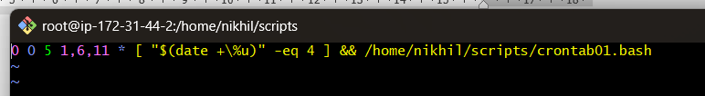
Explanation
Field | Value | Meaning
Minute | 0 | At 0 minutes
Hour | 0 | At 12:00 AM (Midnight)
Day of Month | 5 | 5th day of the month
Month | 1,6,11 | January, June, and November
Day of Week | 4 | Thursday (0 or 7 = Sunday, 1 = Monday, ..., 4 = Thursday)
crontab -l to verify the Crontab
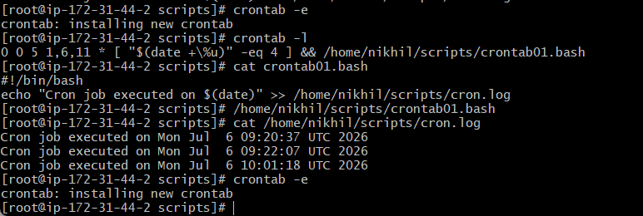
test the script cat /home/nikhil/scripts/cron.log
run the script only on the 5th of January, June, or November when that date is a Thursday.

At05 and 27th minutesof9, 10, 11hours every day
Step 1: Create the file
vi /home/nikhil/scripts/example.bash

Step 2: Paste the script
#!/bin/bash
echo "Cron job executed on $(date)" >> /home/nikhil/scripts/example.log
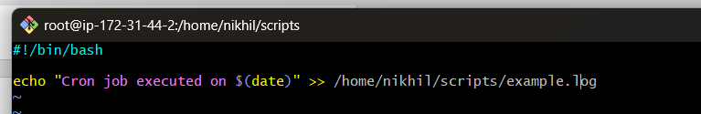

Step 4: Give Execute Permission
Chmod 777 example.bash

Step 5: Add the Cron Entry
Open the crontab:
crontab -e
Add:
5,27 9-11 * * * /home/nikhil/scripts/example.bash
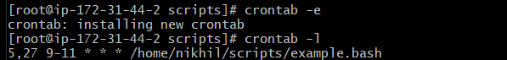

Step 6: Verify the Cron Entry
crontab -l
Expected Output:

5,27 9-11 * * * /home/nikhil/scripts/example.bash
Step 7: Verify the Output
cat /home/nikhil/scripts/example.log
Expected Output:
Cron job executed on Mon Jul 06 10:15:30 UTC 2026
Now the script example.bash will execute every day at:
- 09:05 AM
- 09:27 AM
- 10:05 AM
- 10:27 AM
- 11:05 AM
- 11:27 AM

  - 34 minutesof9th houron15th August
Run the script at 9:34 AM on 15th August every year.
Use the following crontab entry:
34 9 15 8 * /home/nikhil/scripts/example.bash

Explanation
Field | Value | Meaning
Minute | 34 | At 34 minutes
Hour | 9 | 9 AM
Day of Month | 15 | 15th day
Month | 8 | August
Day of Week | * | Every day of the week

Add the Entry
Open the crontab:
crontab -e
Add:
34 9 15 8 * /home/nikhil/scripts/example.bash
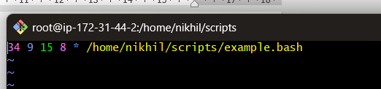
Save and exit.

Verify
crontab -l
Expected Output: 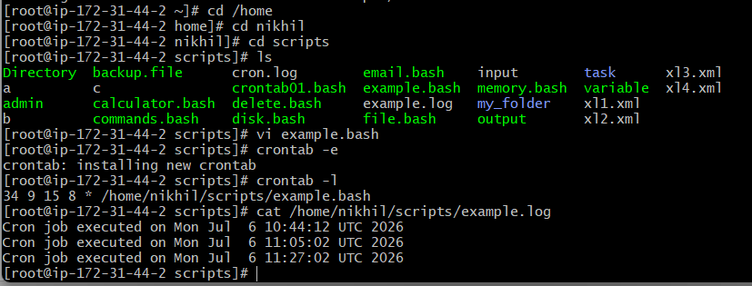
34 9 15 8 * /home/nikhil/scripts/example.bash
This cron job will execute once every year on August 15 at 9:34 AM.

Every midnight.
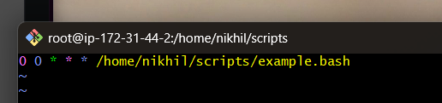
Explanation
Field | Value | Meaning
Minute | 0 | At 0 minutes
Hour | 0 | 12:00 AM (Midnight)
Day of Month | * | Every day
Month | * | Every month
Day of Week | * | Every day of the week
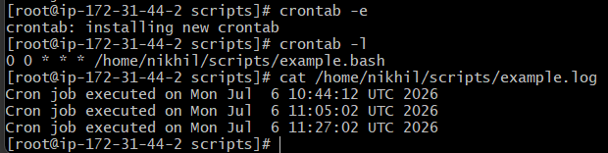

Every Weekend (Saturday night 11:59 PM)
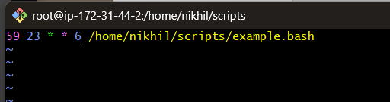
Explanation
Field | Value | Meaning
Minute | 59 | At 59 minutes
Hour | 23 | 11:00 PM hour
Day of Month | * | Every day of the month
Month | * | Every month
Day of Week | 6 | Saturd
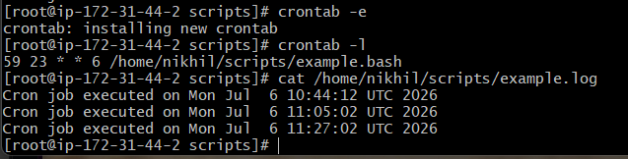

After every reboot.
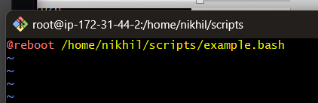
How It Works
- @reboot tells cron to execute the script once every time the system boots or reboots.
- It does not run repeatedly while the system is running—only once after each startup.
